**SOP to determine Log In & Log Out user details in a server**

*Open event viewer in server.

*Select Application & Service Logs on Left side

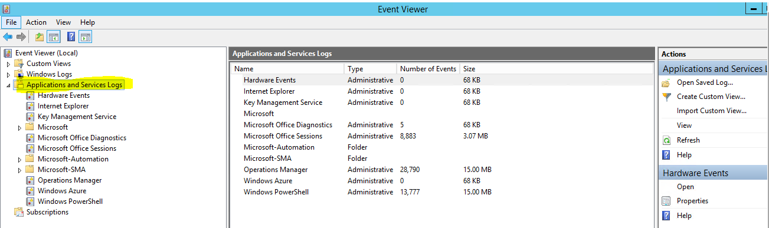

Select **Microsoft -> Windows -> Terminal Services –Local Session Manager -> Operational**

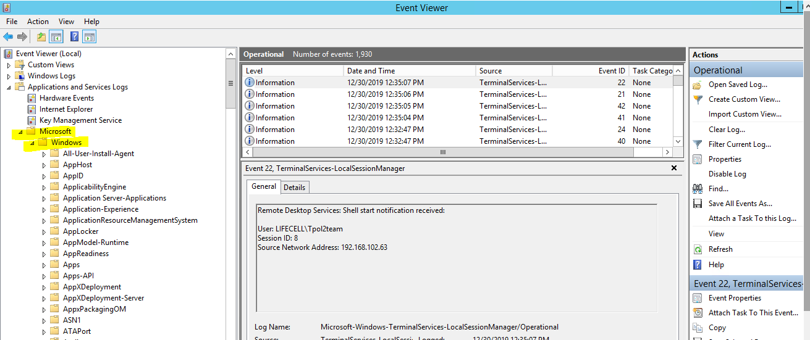

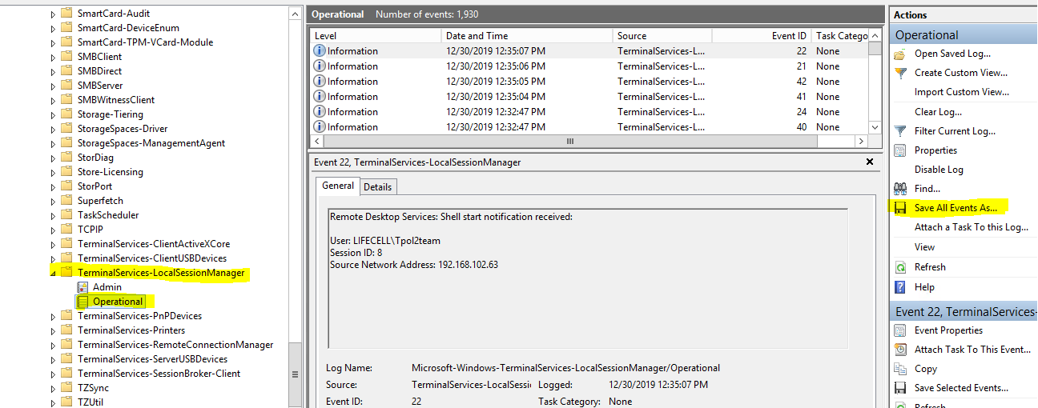

Select -> **Save All Events As** in right side and save file in CSV format in desktop

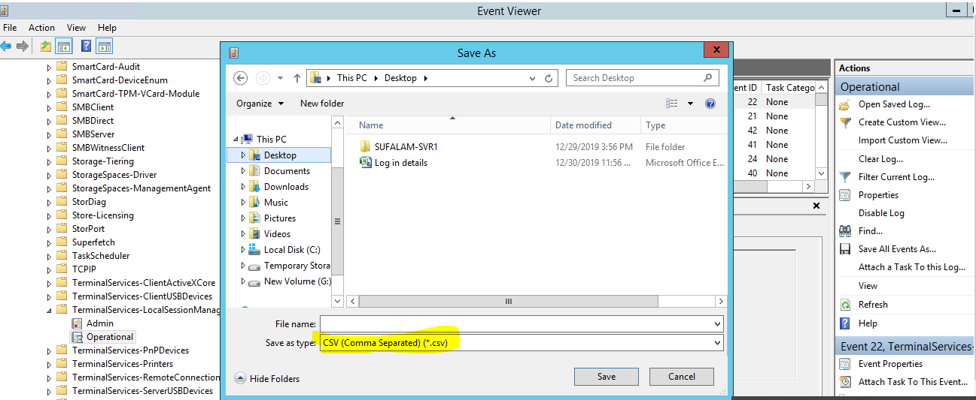

* Open the saved file & Filter the required dates in excel sheet.

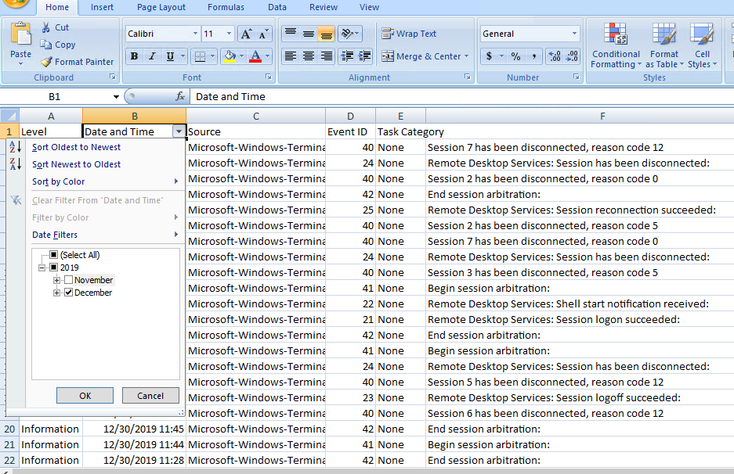

* Remove the remaining Columns and send only **Level, Date &Time, Details of users.**

